Reg No. CODE: COREZOO
Ph.D. COURSEWORK EXAMINATION – SEPT/OCT 2023
SUBJECT: LIFE SCIENCES (ZOOLOGY)
CORE PAPER
Time: 03 hours Maximum Marks: 50
Instructions: Answer all questions
Name: Shalini Tudu

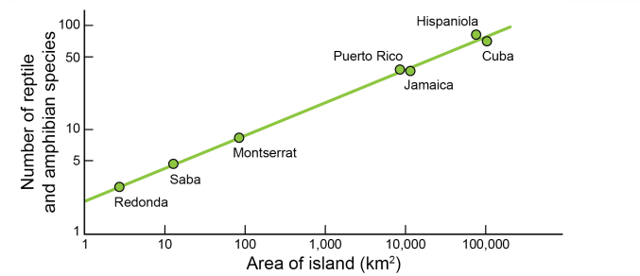
- Figure uses a logarithmic scale on both axes of the graph.

  - Carefully examine the axes and then describe what a logarithmic scale is. ( 2.5 Marks)

  - Why do you think a logarithmic scale was chosen to show these data? ( 2.5 Marks)

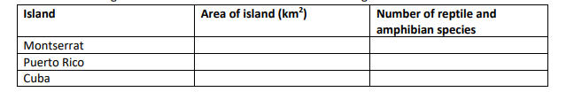
- Fill in the following table with numerical values estimated from Figure . ( 5 marks)

- Using the graph below, answer the following questions (2.5+2.5+2.5+2.5= 10marks)

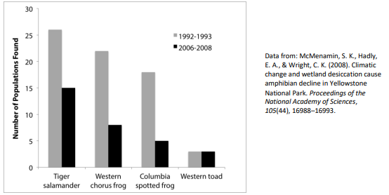

  - Explain, in your own words, what the graph represents.
  - What is the overall trend in the data from 1992-1993 to 2006-2008?
  - What is the overall trend in the data from 1992-1993 to 2006-2008?
  - Which population does not align to the overall trend? Suggest a reason why this population might not have followed the trend.

- Measles is an infectious disease caused by the measles virus. Symptoms include fever, coughing, and rashes. More severe cases may lead to hospitalization and even death, especially for young children. Many countries use a measles vaccine to protect people from the disease. They typically give two doses of the vaccine to increase its effectiveness. The first dose is usually given to infants (in this case, children less than 1 year old). All the vaccination rates reported below are for the first dose. In 2021, the global vaccination rate for measles was about 81%. Samoa, a small island country in the South Pacific Ocean, originally had an even higher vaccination rate for measles. Many rural communities in Samoa were very supportive of vaccination, so Samoa’s vaccination rate was about 92% in 2013. However, between 2013 and 2017, more people moved to urban areas with less vaccine support. As a result, Samoa’s vaccination rate decreased to about 67% by 2017. On July 6, 2018, two nurses made a rare mistake preparing a measles vaccine. They accidentally mixed the vaccine with the wrong liquid, which resulted in the deaths of two infants. While investigating the deaths, the Samoan government paused measles vaccinations for children until November 2018. Because the cause of the deaths was unclear at the time, people became hesitant to use the vaccine. Samoa’s vaccination rate for measles dropped to 40%, and measles cases began to appear by September 2019. In October 2019, while the public was still unaware that measles was spreading, many families gathered for a national holiday, White Sunday, that celebrates children. Unfortunately, these gatherings likely promoted the spread of the measles virus. On November 15, 2019, Samoa declared a state of emergency. The government implemented multiple lockdown measures (when individuals stay where they are to reduce contact with others) — including closing schools, restricting children from public gatherings, and setting curfews. Residents of Samoa were also required to be vaccinated for measles. Over 150 medical teams traveled throughout the country to help vaccinate people. Within six weeks, the vaccination rate of the prioritized groups (children and women of childbearing age) rose to 96%. The state of emergency was lifted on December 29,2019.
- To protect a population against an infectious disease like measles, does everyone in the population need to be vaccinated? Explain your answer, including how vaccines reduce disease spread in a population. (2.5 Marks)

- How would large gatherings help a virus spread? (2.5 Marks)

5a. Describe any two methods of gene transfer with diagrams (5 + 5)
5b. Discuss the significance of employing model organisms with examples.

6a. Explain the mechanism of siRNA and miRNA in gene editing (5 + 5)
6b. Elaborate the significance of DNA fingerprinting with examples

7. Answer the following question (2.5+2.5 marks)
Babies can easily digest milk, the food especially provided for them by their mothers. Later in life, most of us lose this ability because we stop producing lactase, the enzyme that helps us digest the sugar in milk. But about one-third of adults worldwide continue to produce the enzyme, a phenomenon known as lactase persistence. The origin of lactase persistence coincides with a cultural shift in human populations who began to use the milk of other mammals as food.

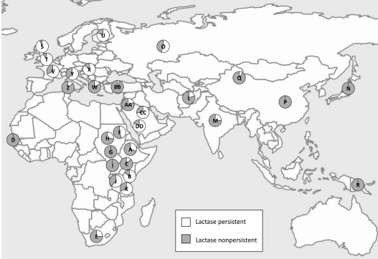
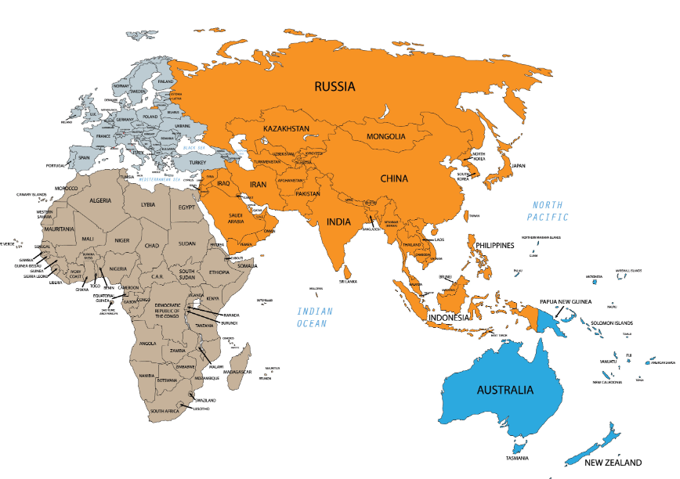
Study the partial world map below. Each pie chart represents a unique population. The unshaded part of each pie chart represents the proportion of the modern-day population that is lactase persistent.
a. Identify two trends from the map. Provide evidence to support each trend.
b. Write a hypothesis to explain the global distribution of lactase persistence and lactase non-persistence. Include the following key terms in your hypothesis: fitness, survival, natural selection.

****************End of the paper********************

